**UNIT -1 (12 MARK Questions)**

**Question No 1: (12Marks)\***

**Describe Eukaryotic cell structure and its function with diagram**

**Eukaryotic cells** are the type of living cells that form the organisms of all of the life kingdoms except monera. The defining feature that sets eukaryotic cells apart from [prokaryotic](https://en.wikipedia.org/wiki/Prokaryote) cells ([Bacteria](https://en.wikipedia.org/wiki/Bacteria) and [Archaea](https://en.wikipedia.org/wiki/Archaea)) is that they have membrane-bound organelles, especially the nucleus, which contains the [genetic material](https://en.wikipedia.org/wiki/Genome) enclosed by the [nuclear membrane](https://en.wikipedia.org/wiki/Nuclear_membrane).

**1.PLASMA MEMBRANE:**

* The cell membrane is the outer layer of the living cell. It controls the passage of materials into and out of the cell.
* The membrane as an inner and outer dense protein layer surrounding a thicker but less dense phospholipid layer.

**2.NUCLEUS**

* The nucleus is a round or oval body lying in the center of the cell. It is surrounded by a double membrane, the nuclear membrane or envelope.
* These membranes coalesce in certain portions of the nuclear envelope, and in these regions, pores (openings) may be formed that provide a route for materials to leave the nucleus directly. .
* Within the nucleus, one or more **nucleoli** may be seen. These are dense bodies containing the subunits for the ribosomes, the cytoplasmic organelles involved in the synthesis of protein.
* It is usually attached to a specific chromosome in the nucleusthe chromosomes look like a single network of thin threads. The gene material of the cell is found in the chromosomes.

3. **CENTRIOLE**

* Centrioles are present as a pair of cylindrical rods in many eukaryotic cells.
* They lie just above the nuclear envelope (membrane),
* Centrioles play a role in the formation of the spindle apparatus, which is an essential feature of both mitosis and meiosis.

**4.MITOCHONDRIA**

* Mitochondria are rounded or cigar-shaped organelles that are particularly prominent in cells with high metabolic activity.
* Mitochondria have a double wall: an outer smooth membrane which forms the outer boundary and an inner membrane which is extensively folded. The folds, or cristae, project into the interior of the organelle and have a variety of enzymes embedded in them.
* These enzymes are involved in the systematic degradation of organic molecules to yield energy for the cell. Like
* The mitochondria contain their own DNA and ribosomes; they replicate independently of the rest of the cell .

**MITOCHONDRIA**

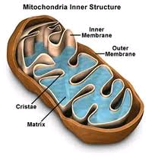

**5. ENDOPLASMIC RETICULUM**

* The endoplasmic reticulum (ER) is a series of membranous channels that traverse the cytoplasm of most eukaryotic cells. It forms a continuous network extending from the cell membrane to the nuclear membrane..
* The endoplasmic reticulum serves many general functions, including the facilitation of protein folding and the transport of synthesized proteins in sacs called cisternae.

**Rough endoplasmic reticulum ER.**

* In many parts of the cell, the endoplasmic reticulum is associated with small dense granules lying along the outer border of its membrane. These structures are known as ribosomes. They impart a rough appearance to the endoplasmic reticulum, so that the ER is called the rough endoplasmic reticulum (RER) in these regions, which are **usually associated with active protein synthesis.**
* The prime rough endoplasmic reticulum function is the production and processing of specific proteins at ribosomal sites that are later exported.
* The next rough endoplasmic reticulum function is to transport these ready proteins to the sites where they are required.

**Smooth endoplasmic reticulum (SER)**

* Smooth endoplasmic reticulum is found in a variety of cell types and it serves different functions in each. It consists of tubules and vesicles that branch forming a network.
* IT is associated with cellular regions which are involved in the synthesis and transport of lipids or the detoxification of a variety of poisons.
* The network of smooth endoplasmic reticulum allows increased surface area for the action or storage of key enzymes and the products of these enzymes. RIBOSOMES

**6.RIBOSOMES**

* Ribosomes are the components of cells that make proteins from all amino acids.
* One of the central tenets of biology, often referred to as the "central dogma," is that DNA is used to make RNA, which, in turn, is used to make protein.
* Ribosomes are made from complexes of RNAs and proteins. Ribosomes are divided into two subunits, one larger than the other.
* The smaller subunit binds to the mRNA, while the larger subunit binds to the tRNA and the amino acids.

**7.GOLGI BODIES**

* They exist as stacks of flattened sacs, or vesicles that are continuous with the channels of the SER.
* Their major function is the **storage, modification, and packing of materials produced for secretory export,** since these organelles are particularly prominent in secretory cells such as those of the pancreas.
* The outer portion of the Golgi apparatus releases its secretory material within membrane-enclosed globules (secretory vesicles) that migrate to the surface of the cell.
* The Golgi apparatus may **actually be part of a dynamic system of membranous channels** within the cell in which all elements such as the nuclear envelope, the ER, the Golgi apparatus, and the cell membrane are connected to each other without sharp boundaries.

**8.LYSOSOMES**

* Lysosomes contain hydrolyzing enzymes that would digest the cellular contents if they were not contained within the impermeable lysosomal membrane. Rupture of this membrane releases these enzymes.
* The lysosome plays a role **in intracellular digestion and may also be important in the destruction of certain structures during the process of development**
* They are frequently nicknamed "suicide-bags" or "suicide-sacs" by cell biologists due to their role in autolysis.

**9.VACUOLES**

* Vacuoles are discrete, clear regions within the cell that contain water and dissolved materials.
* The vacuole may **act as a reservoir for fluids and salts** that might otherwise interfere with metabolic processes occurring in the cytoplasm.
* The membrane surrounding the vacuole is called a tonoplast.
* Vacuoles containing digestive enzymes may also be formed around ingested food particles in a variety of cells.
* In the cells of many plants, a large central vacuole is a prominent feature; this vacuole may swell, press against the rigid cell wall, and give the **cell a high degree of rigidity, and maintains turgor pressure.**

**10.CHLOROPLASTS**

* Chloroplasts are organelles found in plant cells and other [eukaryotic](http://en.wikipedia.org/wiki/Eukaryote) organisms that conduct [photosynthesis](http://en.wikipedia.org/wiki/Photosynthesis). Chloroplasts capture [light](http://en.wikipedia.org/wiki/Light) energy to conserve free energy in the form of [ATP](http://en.wikipedia.org/wiki/Adenosine_Triphosphate) and reduce [NADP](http://en.wikipedia.org/wiki/NADP) to [NADPH](http://en.wikipedia.org/wiki/NADPH) through a complex set of processes called photosynthesis.
* Chloroplasts are observable as flat discs usually 2 to 10 micrometers in diameter and 1 micrometer thick.
* The material within the chloroplast is called the stroma
* Within the stroma are stacks of thylakoids, the sub-organelles, which are the site of photosynthesis. The thylakoids are arranged in stacks called grana (singular: granum).
* A thylakoid has a flattened disk shape. Inside it is an empty area called the thylakoid space or lumen.
* Photosynthesis takes place on the thylakoid membrane; as in mitochondrial oxidative phosphorylation, it involves the coupling of cross-membrane fluxes with biosynthesis via the dissipation of a proton electrochemical gradient.

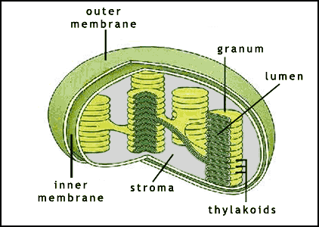

EUKARYOTIC CELL

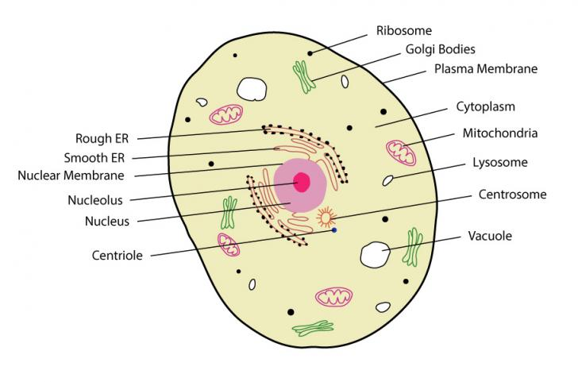

**Question No 2: (12Marks)\***

**Write down the difference between Prokaryotic and Eukaryotic cells**

|  |  |  |
| --- | --- | --- |
|  | **Prokaryotic Cell** | **Eukaryotic Cell** |
| 1.Definition | These are organisms made up of cells that lack a cell nucleus or any membrane-encased organelles. | These organisms are made up of cells that possess a membrane-bound nucleus as well as membrane-bound organelles. |
| 2.Nucleus | It has no nucleus. | It has a true nucleus, bounded by a double membrane. |
| 3.DNA arrangement | It has a circular loop. | It is linear inside chromosomes. |
| 4.Size | Small cells ( < 5 µm) | Large cells ( < 10 µm) |
| 5.Cell | Always unicellular | Mostly multi-cellular except that of PROTISTA |
| 6.Cell wall | Usually present; chemically complex in nature made up of Glycocartex. | When present, chemically simple in nature made up of phospholipids. |
| 7.Protein | It does not contain protein in its DNA. | It contains proteins in the DNA to form chromatin. |
| 8.Ribosome | It contains small ribosomes.  70S Ribosomes | It contains large ribosomes.Ribosobes will be present in Endoplasmic recticulum  80S Ribosomes |
| 9.Cytoplasm | No cytoskeleton | Always have cytoskeleton:  Micro Filaments,Micro tubules and Itermediate filaments |
| 10.Cell division | Cell division is by binary fission | Cell division is by mitosis |
| 11.Reproduction | Reproduction is always asexual | Reproduction is asexual or sexual |
| 12. Ploidy | Usually Haploid cells | Usually Diploid or polyploid |
| 13. Flagella | Consist of two protein building blocks | It is complex in nature and consists of multiple microtubules |
| 14.Multi-cellular forms | Rare | Common with extensive tissue formation |
| 15. Mesosomes | They perform functions of golgi-bodies and mitochondria, and also help in separation of chromosomes. | Not present |
| 16. Plasma membrane | No carbohydrates and lacks sterols | Sterols and carbohydrates are both present |
| 17. Glycocalyx | Present as a capsule or slime layer | Present in some cells which lack a cell wall |
| 18. Example | Bacteria and Archaea | Animal cells and plant cells |

**Question No. 3**

**Describe process of Meiosis**

* Meiosis is a special type of cell division necessary for sexual reproduction.
* Meiosis occurs in germ cells (egg and sperm).
* The diploid number of chromosomes is reduced to haploid number during gamete formation.
* Meiosis results in 4 non identical haploid cells which gives raise to genetic diversity in sexual reproduction process.

**Stages of meiosis** :

* Meiosis – I : Homologous pairs are separated
* Meiosis – II : Sister chromatids of each chromosome are separated
* Meiosis – I
* Synapsis : Homologous pair of chromosomes come together before meiosis begins forming tetrad which is termed as Synapsis.
* Crossing over : The exchange of gene between the tetrad which causes genetic variation is called crossing over.

Prophase –I

* Nuclear memberane disintergrates.
* Nucleolus isappears
* Centrioles moves towards the pole
* Chromatin network coil tightly and form visible chromosomes

Metaphase – I

* The centrioles forms spindle fibers
* The chromosomes are attached to the centrioles forming kinetochore
* The chromosomes are allined at the equatorial plate of the cell

Anaphase – I

* The spindle fiber contract
* The homologous chromosomes are equally divided to both the poles

Telophase – I

* Ch romosomes uncoil to form chromatin network
* Spindle fibred disintergrates
* Nucleolus reappear
* Nuclearmemberane is formed
* Clevage farrow appears in order to facilitate cytokinesis

Cyto kinesis

* The division of cytoplasm into two daughter cells is called cyto kinesis
* Resulting daughter cells are haploid daughter cells

Meiosis – II

* The sister chromatids of each chromosomes are separated
* Chromosomes does not replicate before beginning the second phase meiosis II will divide chromosomes into haploid cells called gamete
* Each haploid cell from meiosis II will go through a second division following the four gametes haploid cell.it has the following phases

Prophase – II

* Spildle fiber formation begins moving towards poles

Metaphase – II

* Chromosomes become aligned at the center of the cell attached to the spindle fiber

Anaphase – II

* Chromatids separate and begin moving to the poles

Telophase – II

* Clevage furrow forms beginning cytokinessis

Cytokinesis :

* The division of each cell cytoplasm into two daughter cells is called cytokinesis
* Resulting in four non identical daughter cells are haploid daughter cells.

Significance:

* All the 4 chromatids of homologous pair of chromosomes segregate and go over separately to 4 different daughter cells this leads to variation in the daughter cells.
* Mternal an parental genes are exchanged during crossing over .It results in variation among the offspring.
* It restrics the multiplication of chromosome number and maintains the stability of the species.

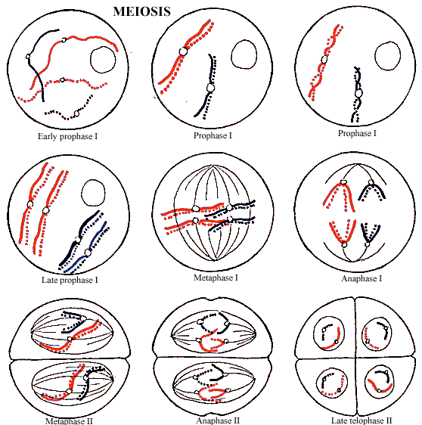

**Question No. 4**

**Describe cell cycle and the process of Mitosis:**

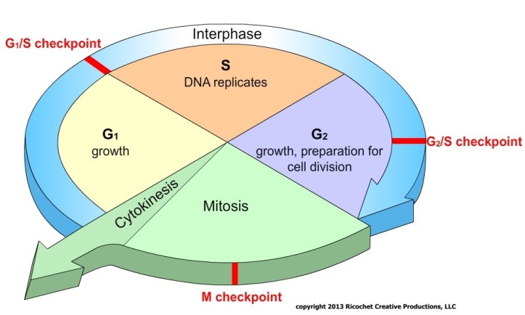

Before a cell can enter cell division, it needs to take in nutrients. All of the preparations are done during the interphase. Interphase proceeds in three stages, G1, S, and G2. Cell division operates in a cycle. Therefore, interphase is preceded by the previous cycle of mitosis and cytokinesis.

**G1 phase:**

The first phase within interphase, from the end of the previous M phase until the beginning of DNA synthesis is called G1 (G indicating *gap*). It is also called the growth phase. This phase is marked by synthesis of various enzymes that are required in S phase, mainly those needed for DNA replication. Duration of G1 is highly variable, even among different cells of the same species.

**S phase:**

The ensuing S phase starts when DNA synthesis commences; when it is complete, all of the chromosomes have been replicated, i.e., each chromosome has two (sister) chromatids. Thus, during this phase, the amount of DNA in the cell has effectively doubled, though the ploidy of the cell remains the same.

**G2 phase:**

The cell then enters the G2 phase, which lasts until the cell enters mitosis. Again, significant biosynthesis occurs during this phase, mainly involving the production of microtubules, which are required during the process of mitosis. Inhibition of protein synthesis during G2 phase prevents the cell from undergoing mitosis.

**Mitosis (M Phase/Mitotic phase)**

The relatively brief M phase consists of nuclear division (karyokinesis). The M phase has been broken down into several distinct phases, sequentially known as:

* Prophase
* Metaphase
* Anaphase
* Telophase
* Cytokinesis (cytokinesis is not part of mitosis but is an event that directly follows mitosis in which cytoplasm is divided into two daughter cells)

**Mitosis** is the process by which a somatic eukaryotic cell separates the chromosomes in its cell nucleus into two identical sets in two nuclei. Mitosis and cytokinesis together define the **mitotic (M) phase** of the cell cycle - the division of the mother cell into two daughter cells, genetically identical to each other and to their parent cell.

* Results in cells such as internal organs, skin, bones, blood, etc.
* These stages are prophase, prometaphase, metaphase, anaphase and telophase.

**Prophase (preparation phase)**

* The DNA recoils, and the chromosomes condense and forms chromosoms
* The nuclear membrane disappears.
* Centrioles moves towards the poles.
* Nucleolous disappear.

**Metaphase (organizational phase)**

* The chromosomes line up the middle of the cell with the help of spindle fibers attached to the centromere of each replicated chromosome.
* Kinetochore – It is a complex of proteins associated with the centromere of a chromosome during cell division, to which the microtubules of the spindle attach.

**Anaphase (separation phase)**

* The chromosomes split in the middle and the sister chromatids are pulled by the spindle fibers to opposite poles of the cell.

**Telophase**

* The nuclear membrane is formed.
* Centrioles disapper.
* Nucleolous reappear.
* The chromosomes, along with the cytoplasm and its organelles and membranes are divided into 2 portions.

**Cytokinesis**

The actual splitting of the daughter cells into two separate cells is called cytokinesis and occurs differently in both plant and animal Cells.

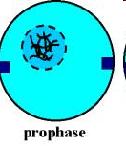 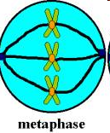 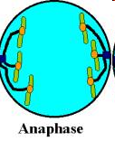

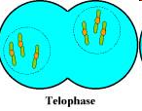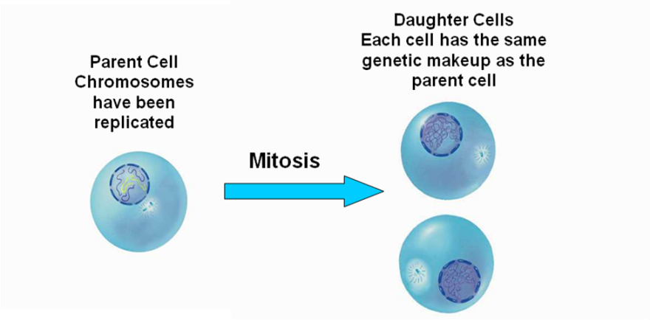

**Question No. 5**

Expalin homeostasis with example

The concept of homeostasis is the description for when the internal conditions of living organisms remain stable. These internal conditions include your body temperature, pH level, and glucose level.

● Homeostasis maintains your system in a normal range; if toxins accumulate in your system, homeostasis would be disrupted, and you would become very sick.

**Definition:** Maintenance of the relative stability of the physical and chemical aspects of the internal environment within a range compatible with cellular function. The maintenance of constancy is called homeostasis.

Homeostasis has been studied most intensively in multicellular animals, particularly vertebrates.

However, it is operative at all levels of life. Those processes that maintain homeostasis are known as homeostatic mechanisms.

Components: 1) sensor

2) afferent pathway

3) integration center or comparator

4) efferent pathway

5) effector organ(s)

* Negative feedback : a control system that causes the value of a physiological measurement to change in the direction **opposite** to the initial deviation from set point.
* Positive feedback: a control system that causes the value of a physiological measurement to change in the **same** direction as the initial deviation from set point.

**Temperature Homeostasis**

● One of the most important examples of homeostasis is the regulation of body temperature.

● Heat is produced within your body as a result of metabolic activities such as cellular respiration. High levels of cellular respiration takes place in the muscles and liver. Thus, a large amount of heat is released in these organs. The heat is distributed to the rest of your body via the bloodstream.

● The body can also gain extra heat through: - vigorous muscular exercise” - the consumption of hot food; and - being in warm environments ( e.g. being outdoors on a very hot day ).

● Excess heat needs to be removed from the body. If not, one could die of overheating.

● Heat is lost: - through your skin by radiation, convection and, to a limited extent, by conduction; - by evaporation of water in sweat from the surface of your skin; - in the shit and urine; and - in the air that is exhaled.

● Certain parts of your skin contain shunt vessels. These vessels connect the skin arterioles with the skin venules. They control the amount of blood flowing through your skin capillaries, which in turn affect heat loss through your skin surface,

● **The hypothalamus in brain monitors and regulates your body temperature**. The hypothalamus receives information about temperature changes from two sources - **thermoreceptors** in skin which detects temperature from the environment and **thermoreceptors in the hypothalamus** which detect temperature of the blood.

● During vigorous muscular activities, a large amount of heat is produced. On a warm day, the rate of heat loss is reduced. The heat produced accumulates in your body and causes a rise in your blood temperature. This change is detected by the hypothalamus, causing it to send out the nerve impulses to the relevant body parts to bring about the changes.

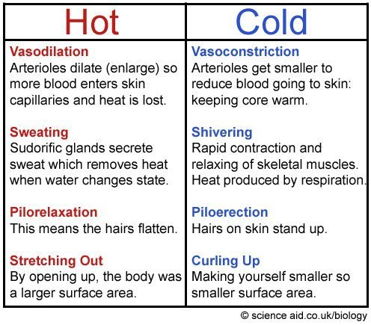

**Blood pressure maintenance :**

● Another example of homeostasis is maintaining Blood Pressure.

● The maintenance of healthy blood pressure is an example of homeostasis. The heart can sense changes in the blood pressure, causing it to send signals to the brain, which then sends back signals telling the heart how to respond.

● If blood pressure is too high, naturally the heart should slow down; while if it is too low, the heart wants to speed up. Blood Pressure

GLUCOSE REGULATION:

Our bodies desire blood glucose to be maintained between 70 mg/dl and 110 mg/dl (mg/dl means milligrams of glucose in 100 milliliters of blood).

* Below 70 is termed "hypoglycemia." Above 110 can be normal if you have eaten within 2 to 3 hours.
* The glucose should be below 180. Above 180 is termed "hyperglycemia"

**HYPER GLYCEMIA**

Insulin is normally secreted by the beta cells (a type of islet cell) of the pancreas. The stimulus for insulin secretion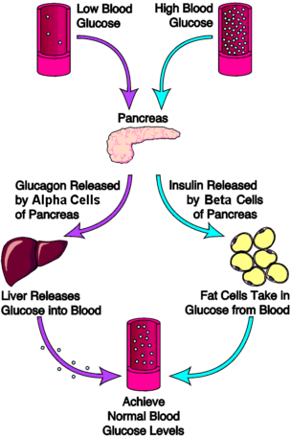 is high glucose level. There is always a low level of insulin secreted by the pancreas, the amount secreted into the blood increases as the blood glucose rises.

Insulin has an effect on a number of cells, including muscle, red blood cells, and fat cells.  In response to insulin, these cells absorb glucose out of the blood, having the net effect of lowering the high blood glucose levels into the normal range.

GLUCOSE insulin GLYCOGEN

**HYPOGLYCEMIA**

Glucagon is secreted by the alpha cells of the pancreatic islets in much the same manner as insulin.. If blood glucose is high, then no glucagon is secreted.

When blood glucose goes LOW, however, (such as between meals, and during exercise) more and more glucagon is secreted. Like insulin, glucagon has an effect on many cells of the body, but most notably the liver.

The effect of glucagon is to make the liver release the glucose it has stored in its cells into the bloodstream, with the net effect of increasing blood glucose. Glucagon also induces the liver (and some other cells such as muscle) to make glucose out of building blocks obtained from other nutrients found in the body (eg, protein).

GLYCOGEN Glucagon

GLUCOSE

**Question No. 6**

Explain Prokaryotic cell structure:

Bacteria are prokaryotic organisms that reproduce asexually. Bacterial reproduction most commonly occurs by a kind of cell division called binary fission. Binary fission results in the formation of two bacterial cells that are genetically identical.

**Bacterial Cell Structure**

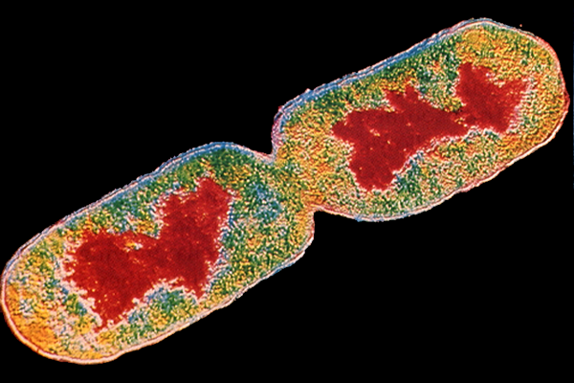

**DNA**

**cell wall**

Bacterial cells typically contain the following structures: a cell wall, cell membrane, cytoplasm, ribosomes, plasmids, flagella, and a nucleiod region.

Cell Wall - Outer covering of the cell that protects the bacterial cell and gives it shape.

Cytoplasm - A gel-like substance composed mainly of water that also contains enzymes, salts, cell components, and various organic molecules.

Cell Membrane or Plasma Membrane - Surrounds the cell's cytoplasm and regulates the flow of substances in and out of the cell.

Flagella - Long, whip-like protrusion that aids in cellular locomotion.

Ribosomes - Cell structures responsible for protein production.

Plasmids - Gene carrying, circular DNA structures that are not involved in reproduction.

Nucleiod Region - Area of the cytoplasm that contains the single bacterial DNA molecule.

Bacterial Reproduction: Asexual

Most bacteria reproduce by binary fission. During binary fission, the single DNA molecule replicates and both copies attach to the cell membrane.  
  
The cell membrane begins to grow between the two DNA molecules. Once the bacterium just about doubles its original size, the cell membrane begins to pinch inward.  
  
A cell wall then forms between the two DNA molecules dividing the original cell into two identical daughter cells.

* Binary fission is a method of asexual reproduction by most prokaryotes. In binary fission, the living cell divides into two equal, or nearly equal, parts. It begins when the DNA of the cell is replicated.
* Each circular strand of DNA then attaches to the plasma membrane. The cell elongates, causing the two chromosomes to separate.
* The plasma membrane then invaginates (grows inward) and splits the cell into two daughter cells through a process called cytokinesis.
* Binary fission theoretically results in two identical cells. However, the DNA of bacteria has a relatively high mutation rate. This rapid rate of genetic change is what makes bacteria capable of developing resistance to antibiotics and helps them exploit invasion into a wide range of environments.

**Question No. 7**

**Expalin Prokaryotic Cell Division**

**BINARY FISSION**

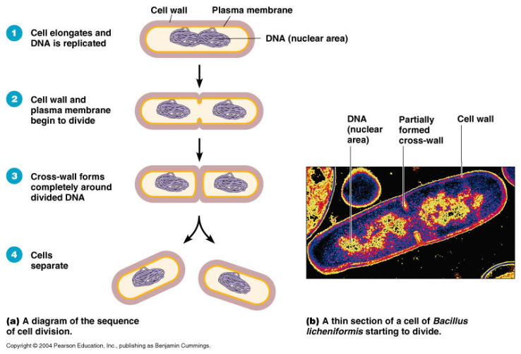

**Bacterial Recombination:**

**Conjugation**

Some bacteria are capable of transferring pieces of their genes to other bacteria that they come in contact with. During conjugation, one bacterium connects itself to another through a protein tube structure called a pilus. Genes are transferred from one bacterium to the other through this tube.  
**Transformation**  
Some bacteria are capable of taking up DNA from their environment. These DNA remnants most commonly come from dead bacterial cells. During transformation, the bacterium binds the DNA and transports it across the bacterial cell membrane. The new DNA is then incorporated into the bacterial cell's DNA.  
  
**Transduction**

Transduction is a type of recombination that involves the exchanging of bacterial DNA through bacteriophages. Bacteriophages are viruses that infect bacteria. There are two types of transduction: generalized and specialized transduction.